**Training Claymore Report**

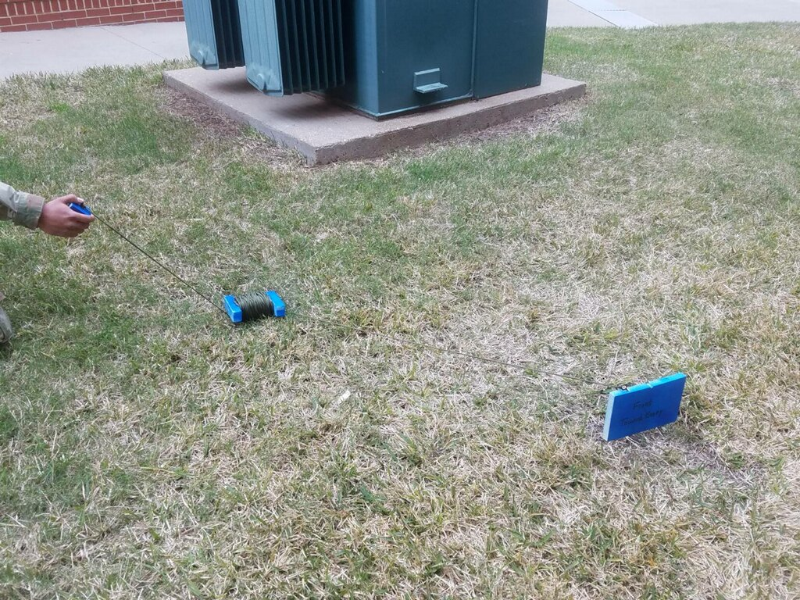

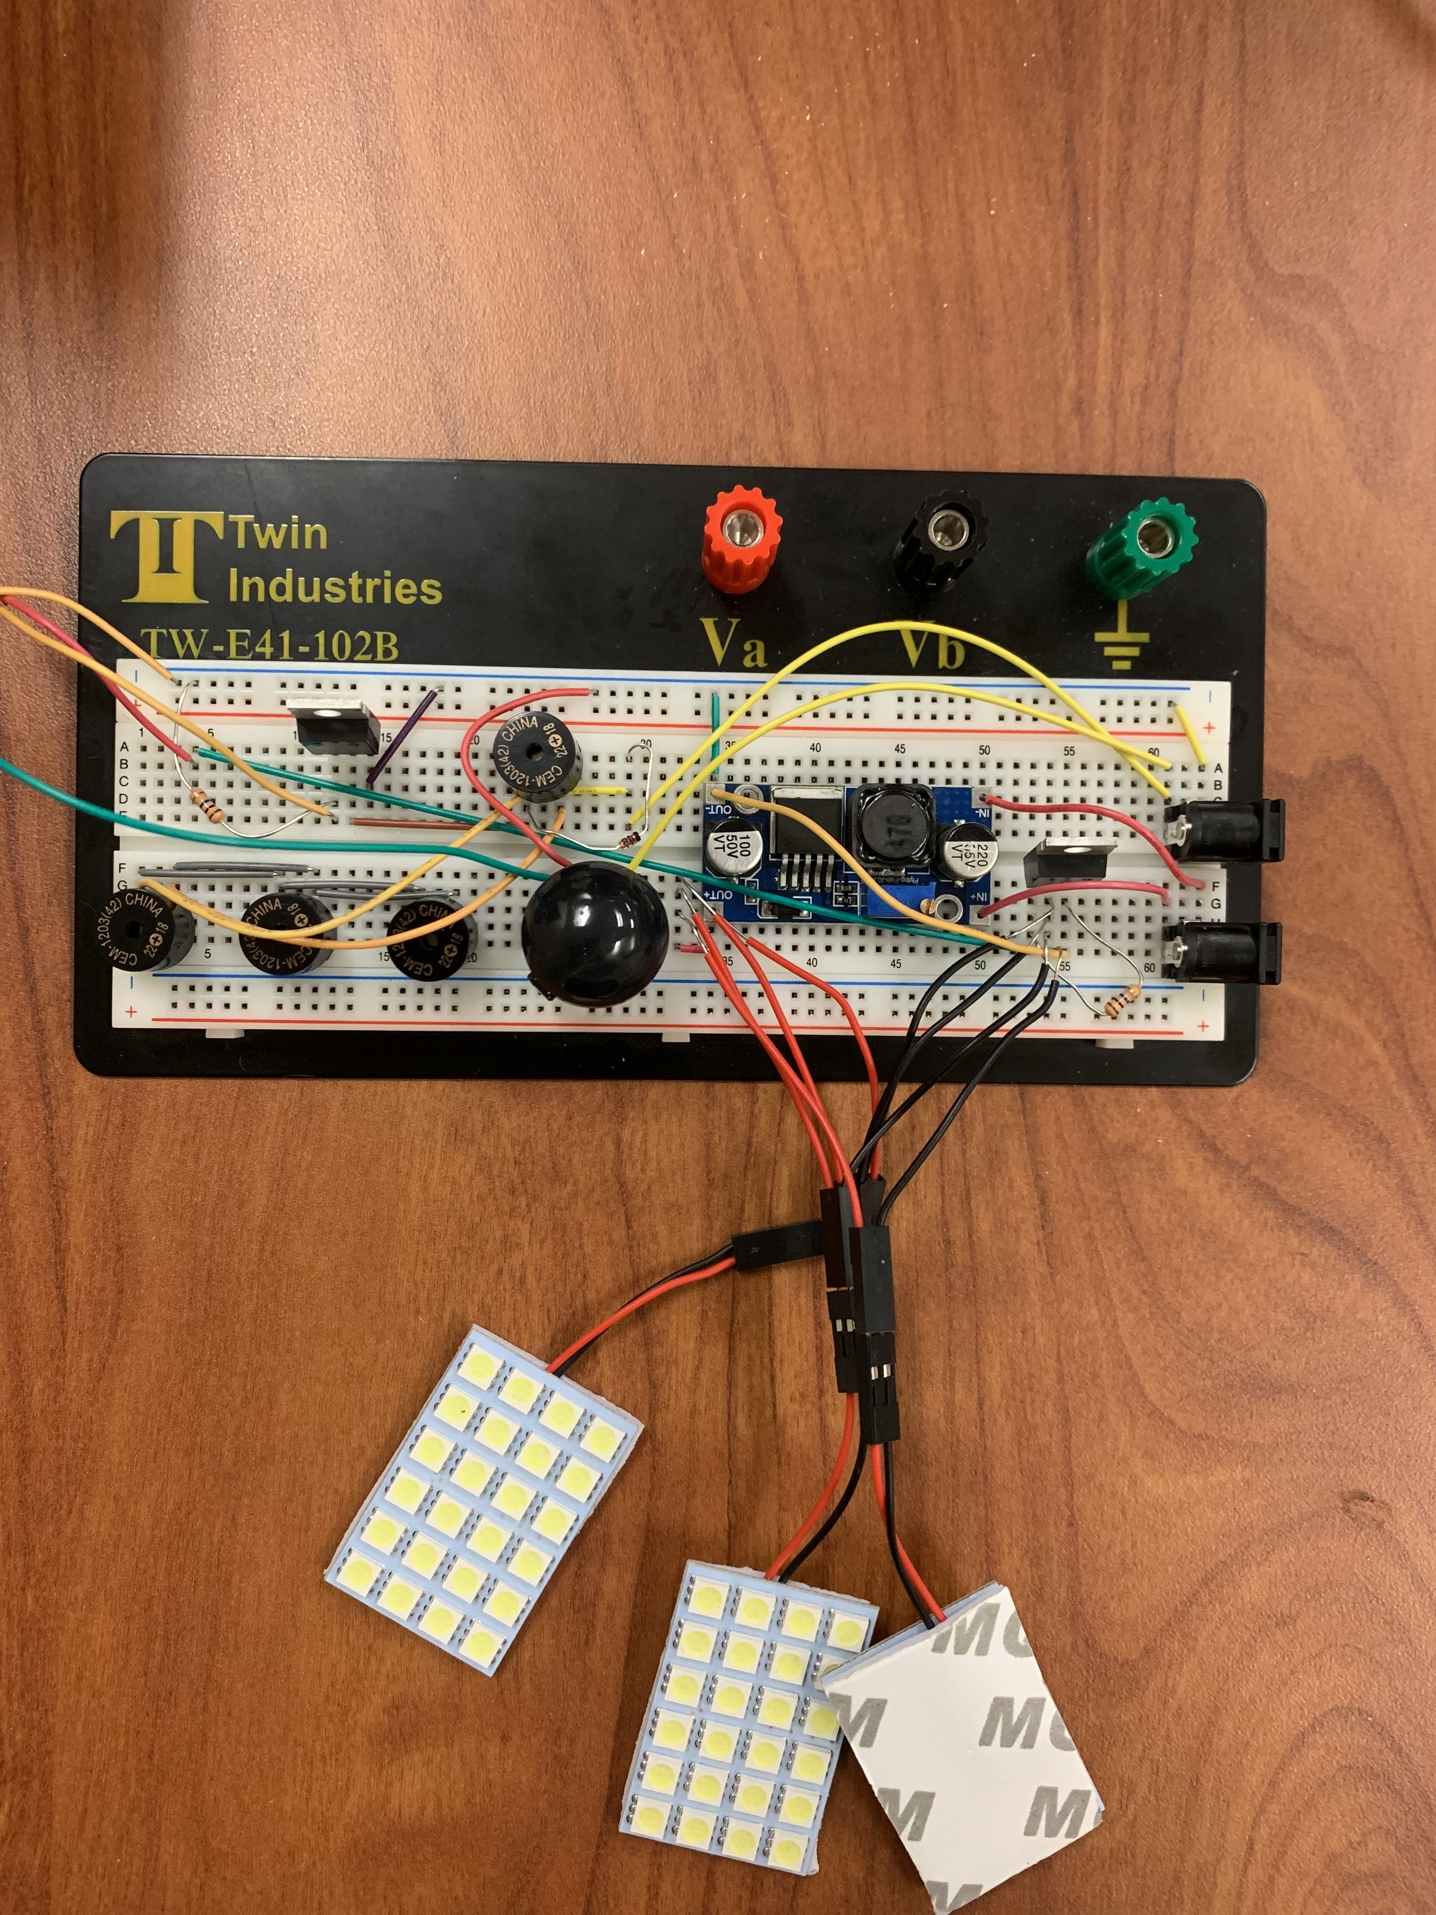

Sam Skinner and Sam Malhotra

**Summary**

This device is a training claymore that flashes lights and makes noise when triggered. A claymore is a manually triggered directional explosive device used by the U.S. military. It uses C-4 explosives to launch steel balls into a wide spray like a shotgun. Baylor Army ROTC uses training claymore during tactical exercises, but these claymores are just blocks of wood and do not do anything when “triggered.” In order to enhance the training by making a claymore that actually had effect when triggered, this device was created.

This device mimics a real claymore but uses lights and noise to simulate the explosion instead of exploding. The device also does not use wire connecting to a physical trigger. Instead, it uses a webpage which allows the user to select from a manual trigger and motion sensing. Using a cell phone, the user can connect to a BeagleBone Black Wireless through the BeagleBone’s Wi-Fi. From there, the user can open a webpage and select whether to trigger the claymore manually or use motion sensing to trigger it. When it is triggered, 4 LED panels flash and 4 small magnetic buzzers go off for ten seconds.

**Objectives**

1. Portable: The device will be used in a field environment. It needs to be carried to the training location with just the use of a backpack.
2. Effects on “enemy”: When the device is triggered, it should be noticeable to everyone in the area, and it should be mildly shocking to the “enemy” in the training scenario.
3. Triggered from a webpage: The device should be wirelessly triggered by connecting to the BeagleBone’s Wi-Fi and opening a webpage with the trigger method and a button for the manual trigger.
4. Durable: The device needs to be used in harsh conditions including rain and being roughly handled. The device should continue to operate regardless of the environment it is in.

**Hardware Platform**

The BeagleBone Black Wireless (BBBw) is the hardware platform for this device. Although it has much higher battery consumption than a microcontroller, the BBBw has built in Wi-Fi capabilities that microcontrollers do not. This device requires the ability to connect wirelessly to the BBBw and to connect to a webpage using the BBBw’s Wi-Fi. Power consumption should not be an issue because the device only needs to be powered for a couple hours at a time. Besides the webpage, the inputs and outputs of the device are fairly simple and do not take much extra effort to connect to the BBBw.

**Hardware Design**

Figure 1 below shows the hardware design of our entire device.

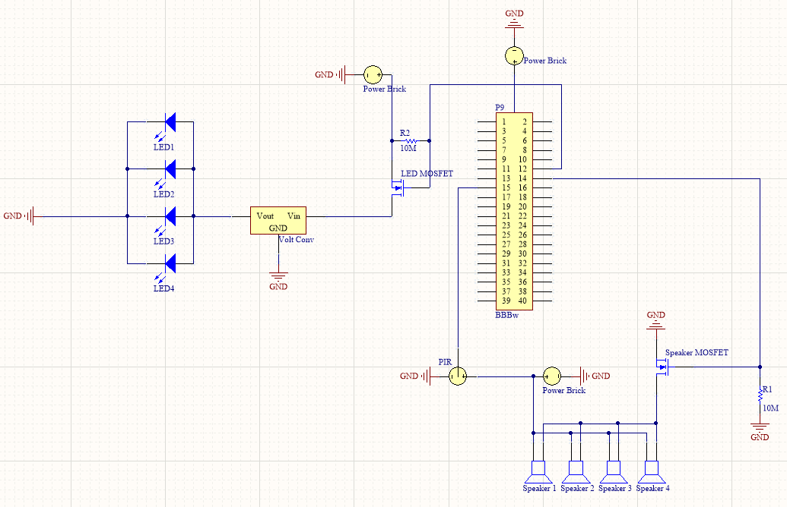

Figure 1 - Hardware design schematic

All components on this project were powered by a power brick that was capable of providing 4.8V out of each of its three power ports simultaneously. This power source was chosen for its ability to provide up to 22Ah as well as its potential to power multiple systems at the same time. In this case, the brick powered a BBBw, the LED system, and the PIR and magnetic buzzer system. The power brick is also very easy to charge requiring only a wall plug to micro-USB similar to most cell phone chargers today. The BBBw received power directly from the power brick through power port 1.

The four LED panels were connected in parallel and received power from the power brick through power port 2. However, to achieve full brightness of the LEDs, a voltage converter was used between the power brick and LEDs to boost the voltage from 4.8V to 12V. A PSMN2R0-30PL MOSFET acted as the switch between the power brick and LEDs and was controlled by the P9.12 pin on the BBBw. The LEDs pulled about 5 amps, so the purpose of the MOSFET was to isolate the LEDs from the BBBw due to current and voltage restrictions for the BBBw.

In a similar fashion, the PIR and magnetic buzzers received their power from power port 3. Again, a MOSFET was used as a switch while also isolating the BBBw from dangerously high currents required by the magnetic buzzers.

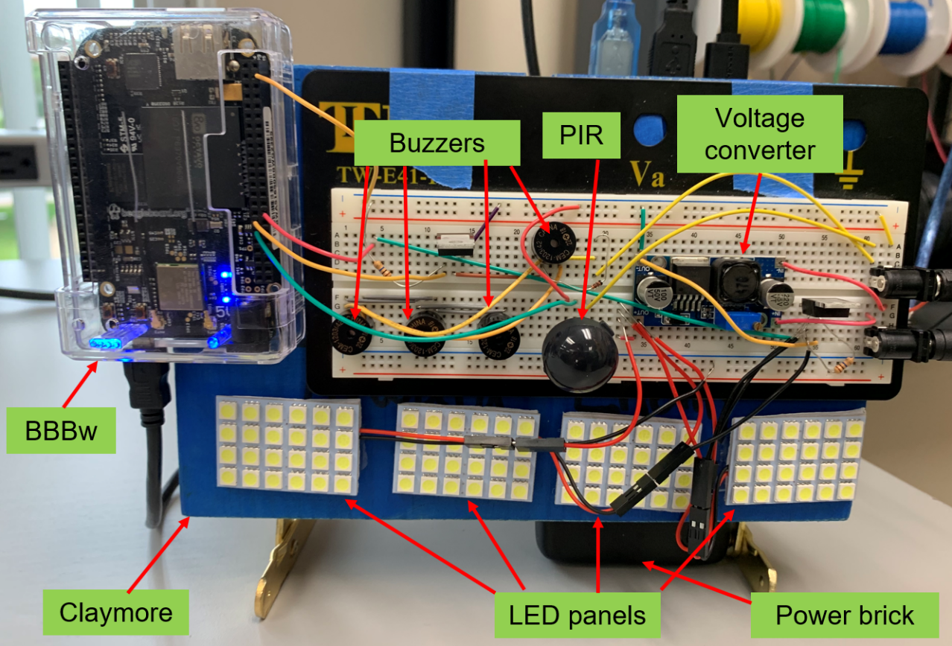

Figure 2 - Hardware implementation

A brief summary of each hardware component is included below, along with part specifications:

1. **Beaglebone Black wireless (BBBw)**

* Has PWM capabilities to power the magnetic buzzers
* GPIO pins were used to toggle the MOSFETs
* Built in WIFI capability which was used to host the web interface

1. **Claymore**

* Made out of wood and steel components
* Simulates approximate dimensions and weight of actual M18 Claymore

1. **Magnetic Buzzer -** CEM-1203(42)
   * Four of these buzzers were connected in parallel pulling a combined 140mA
   * Each buzzer was capable of outputting 95dB
2. **4.8V Power brick** **-** RAVPower Portable Charger

* Capable of providing 22000mAh
* Supplies up to 5.8A
* Has three output ports

# LED Panels - Everbright 5-Pack White 5050 24SMD Led Panel

# 288 Lumens

# 24 LEDs on each panel for a combined total of 96 LEDs on the Claymore

# Has adhesive on the reverse side for easy installation and replacement

# Voltage Converter - eBoot Boost Converter Module XL6009 DC to DC 3.0-30 V to 5-35 V

* Easy Adjustment knob
* Capable of boosting voltage to optimal levels for the LED panels

1. **PIR sensor –** EKMC2603112K VZ type long range detection

* Compact component
* 12m detection range, which was the furthest distance we could find within our budget
* Very low power (pulls 0.17mA)

**Software Platform**

This device runs 3 different software languages: C, JavaScript and HTML. The code in C runs the actual processes that the claymore does when it is triggered. The JavaScript and HTML create the webpage and pass information from it to the C code. C was chosen because all the effects that needed to happen already had code written. This code just needed to be slightly changed to fit the application. JavaScript and HTML were chosen because they were the simplest languages to create a webpage for this device.

**Software Design**

Figure



Figure 3 - High level software design

Stufffffff

# Test Results

This project successfully met our design criteria and fulfills its operating parameters. The webpage is easy to navigate and allows the user to successfully choose the trigger method (manual or PIR) and then trigger the device. The LEDs and magnetic buzzers provide a noticeable alarm that alerts the operator and anyone else with sight and sound of the system that it has been triggered. Through trail and error, it was estimated that the WIFI signal output by the BBBw was functional out to about 50m. It was also estimated that the PIR sensor was capable of being triggered by targets at a max range of 14m. Based on the rated angle of detection and range of the sensor, it was calculated that the PIR had an active detection area of 189 square feet on the ground in front of it.